A Comprehensive Guide to Javelin Made By Steadman

General Information
Javs have 1500 total energy.

Bombs
-Cost 1100 energy
-Bounce once before exploding and continue until they make contact with a player or wall
-Look smooth before they bounce and jagged afterwards
-Appear on radar in most TWJD-style arenas
-Bounce after hitting a corner perfectly (these are important to account for and dodge)
-Do not kill full energy enemies when up close. These are known as close bombs (referred to as CB from here on)
-Any damage that you take from your OWN bombs is mitigated from ALL other players (This is why CBs don't kill full energy enemies)

Bullets
-Cost 300 energy
-Deal 520 damage
-Shoot out twice as fast when using single-fire rather than multi-fire

Miscellaneous
-You can exit base if you recently entered it. This triggers a 15-second timer to re-enter base before getting +1 death. Great for cheesing kills or running to safety.
-Your ship needs to completely pass the “DO NOT CROSS” line in order to get +1 death or a warning.

Recommended Settings
Client Settings
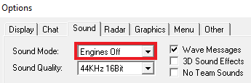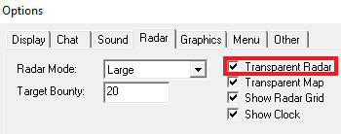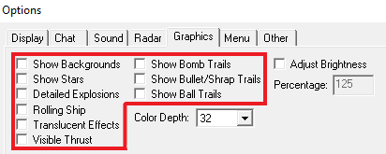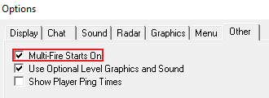

-Turn off: Engine Sounds, Show Backgrounds, Show Stars, Rolling Ship, Visible Thrust, and Bomb/Bullet Trails as these can distract you or misconstrue projectile locations
-Turn on: Transparent Radar, Multi-Fire Starts On, and Big Bullets (File and instructions at https://forums.trenchwars.com/support/1321560-new-bigbullets-4x-upscale)

Key Bindings
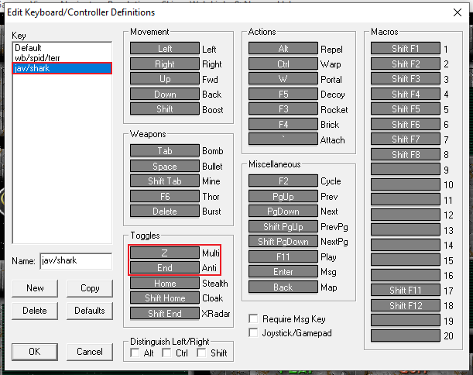

-Set Anti-Warp to a single, easy to press key
-Set Multi-Fire to a key you can easily press with your left hand

Resolution
Swapping resolutions frequently will prevent you from properly adjusting to it, so pick a res, stick to it, and master it (talking to you aggi). I’ve had successful TWLJ seasons on 1280 x 1024, 1600 x 900, and 1920 x 1080, so all of these resolutions are viable at any level of play. With that being said, bigger resolutions will always be objectively better than smaller resolutions as long as they don’t affect your performance. A larger resolution offers you a wider lens to view the game as well as more information. This means that if you can fly, dodge, bomb, and 1v1 at the same level on both 1600 and 1920 resolutions, you should be using 1920. If upping your resolution means you miss walls, lose trades, and whiff bombs, you’re better off staying where you’re at.

Goals
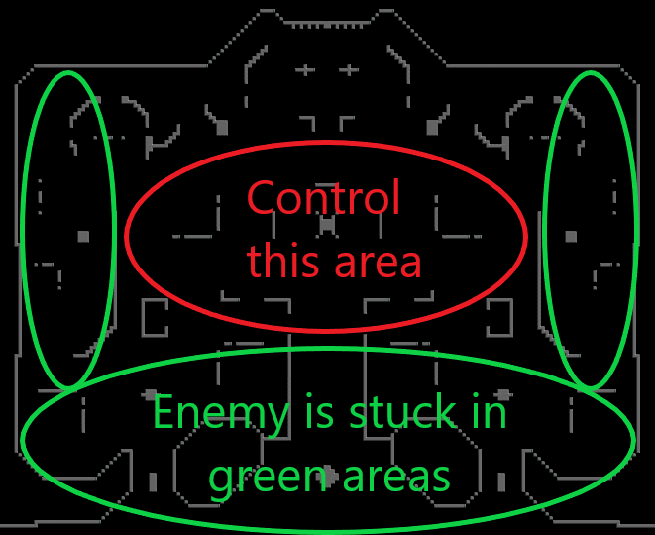

Your basic goal in jav is to control mid-base and overwhelm the enemy with strays/bullets/numbers advantage. Controlling base allows you to fire bombs from a better vantage point, cover your teammates more easily, and apply pressure to enemy fighters. When the enemy is clumped up and has little space to move, they're more likely to die to strays and 2fers, which makes it difficult to find counterplay.

There’s Levels to this Game
The 3 levels of jav are beginner (6-7.5*), intermediate (8-9*), and elite (9.5-10*). Beginner level players struggle in every facet of the game. This includes but is not limited to flying, killing, shot-taking, and teaming. As a result, having beginner players on your team means less pressure in base. This is because beginners stray unlikely lobs, run, and hide behind walls rather than setting up plays for their teammates and generating pressure. Intermediate players can trade 1-for-1 kills in most situations and have some grasp of teaming/pushing, but their success is subject to the state of the game. These players look strong when they're on dominant teams but perform poorly in tougher situations. Intermediate players are typically afraid to bomb first (they refuse to practice it) and will focus on luring bad shots or bulleting. If you're an intermediate level player, this is your best playstyle for winning games, but you’re not improving by avoiding these facets of the game. There are some intermediate players that can fill a role on an elite team but they are few and far between. Elite players know what their role is in a given game and execute properly. These are players who can carry or turn the momentum of a game at will. To become an elite player, you need to play situations optimally and come out with a neutral or positive overall result for your team. Elite players impact the game, aren't afraid to fire first, and most importantly they withstand the pressure of the enemy team without backing down (unless necessary).

Know your Role and Adapt
The two main roles in jav are support and carry. No role is superior to the other and a balanced team needs a few of each. Supports lure and pressure the enemy into difficult spots so that carries can grab easy kills. It's important for players to recognize what's needed in a team and to be able to play BOTH roles at will. If you see that your team is full of players who bomb frequently, your time is better spent pressuring and setting up shots. If you’re by far the best player on your team, then you need to bomb more aggressively and rack up kills. Teams where players don't know their role are significantly more likely to lose because of a lack of pressure in base and synergy with the team. If I find myself in a situation where the enemy team limits my movement and vulches me every time I get a kill, I will never be able to impact the game.

Make Sure It’s Safe to Fire
This is BY FAR the most important thing you will read in this guide. Watch for any bullets or bombs headed your way and show restraint if they're going to kill you. If you see that something will hit you right after you bomb, DON'T TAKE THE SHOT. Most deaths are caused by user error and are completely avoidable. This is because jav is a naturally defensive ship and it’s very hard to force someone to die (Source: 2 hour 1v1 TWEL duels). It is significantly easier to die if you just bombed than if you’re sitting at full energy.

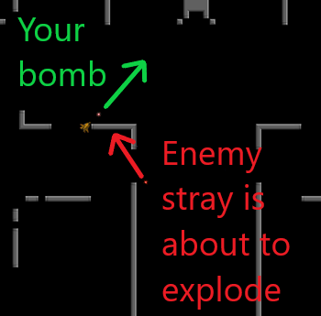

As you can see in this graphic, this player just bombed and, as a result, the stray will kill them. He would have lived if he recognized that the bomb was coming and withheld from shooting. The enemy bomb isn’t very close to the ship, so you could expect it to do approximately 1100 damage when it hits the wall (keep in mind that the ship will move away from the wall by the time the bomb explodes).

LEARN TO DRIVE THE SHIP
Jav is a mammoth on ice skates. It's heavy, it’s momentum driven, and if it doesn't feel good in your hands then chances are you won't do well. Jav is 90% positioning and ship control because you need to get into specific positions in order to hit certain shots. If your jav feels slow, go to a private arena and drive a lev for a few minutes. Once used to how heavy a lev feels, your jav will feel much more nimble in comparison. If you're serious about improving, take a few minutes a day and ?go #twlj to practice flying without shifting. Doing so will help you get the feel of the ship's base speed.

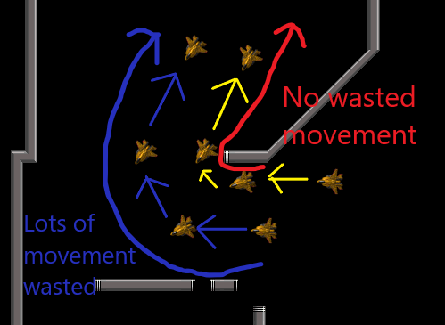

Being able to fly close to walls is more efficient than flying far away from them because there is less wasted movement and, therefore, less wasted time when running away from or chasing an enemy. If you have no wasted movement while running away, it’s completely impossible for someone chasing you to gain ground. This is why running on full energy is so OP. Being able to get as close to walls as possible WITH and WITHOUT shift puts you into the 97th percentile in jav flying. If you want to prove your flying skills, you should be able to get so close to a wall that pressing into the wall would completely stop your momentum (wall stop). Keep in mind that always flying near walls would make you predictable and become punishable over time. Another drawback is that it’s significantly harder to bomb off a wall if you’re super close to it, since you have less time to position yourself and aim.

Stop Clumping Up
This one is pretty self-explanatory; if other team have energy for pew-pew you do not make a doo-doo on your teammate. There are some situations where it’s okay or even necessary to clump up, like when rushing a low energy enemy. Use your discretion and do what the situation calls for.

Stop Blocking Your Mate’s Shots
If your teammate has the perfect opportunity to kill someone then get the fuck out of the way or accept that you're going to be 2ferred, and deservedly so. This is especially true if you know your teammate bombs frequently or if the enemy is better than you, because then the trade is actually worth it. For example, if I 2fer my team's 7* jav and the enemy 10* jav, that's a trade I'll take all day. This leads to my next point.

Trade Up
If you have the opportunity to trade with a better player, then by all means go for it. Especially if they’re on high deaths and you're not. And especially if your team has a lead and you have deaths to spare. It doesn’t make sense to trade with better players if you’re on high deaths and they’re not.

They Bounce
Crazy concept but if you see a bomb fly past you before it bounces, it's going to come back. Keep this in the back of your mind every time you see a straggler bomb pass by. More difficult to implement but equally important is thinking about where your bomb will end up after bouncing. Try to avoid teamkills with obvious bad shots.

Ah Ah Ah Ah Stayin’ Alive
You’re on 9 deaths in a close game, or maybe even a blowout. Your one job? Stay the fuck in the game. Staying in on 9 is the difference maker in every close game. If the enemy team can’t get you out then they can’t push a numbers advantage onto your team. If you have to sacrifice or abandon your teammates who are not on 9, it's worth it. If your teammate is on 9 and you’re not, stay close but not so close that you’ll 2fer them. Chances are the enemy will try to dive your team’s high death players and you can score a free kill or two. You should play like you're on your last death BEFORE you're on your last death, usually starting around 7 or 8 deaths. But if you’re on 7 and the rest of your team is on 9 in a close game, it’s time to start being proactive and making plays.

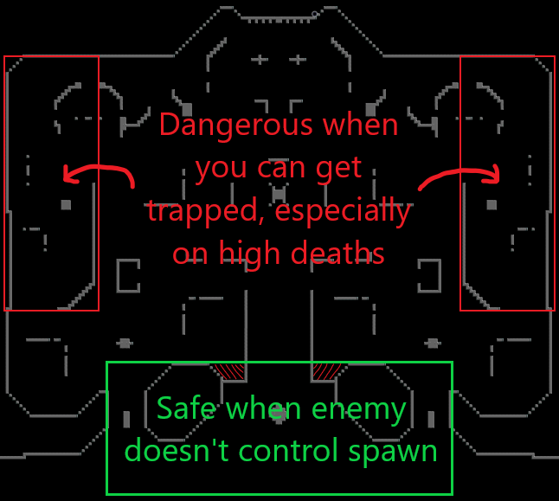

Most people don't realize this but the safest place in the game is just outside of base (unless the enemy controls spawn). If you're in the dangerous areas when you’re on 9 and your team just wiped, chances are you'll be collapsed on, trapped and killed - so stay near those entrances/exits and stray while you run away. Just to be clear, what areas are safe or dangerous are constantly changing based on the flow of the game and it’s up to you to read where those areas are. I go to the “dangerous areas” all the time because the long walls provide safety from strays and bullets. The danger only occurs when you get outnumbered and collapsed on in those areas, as it is the easiest location to trap players and go in for guaranteed kills. However, when you and your team are in the dangerous zone, you’re only there to avoid danger and recharge any missing energy so that you can mount a counter-attack. If you’re on the offensive vs. players in the dangerous zone your goal is to keep them there and finish them off.

Try to Balance Your Deaths with Your Teammates’ Deaths
If you have higher deaths than your team, take things down a notch. If you have lower deaths, play a little riskier and be more willing to trade kills. But with that said, ALWAYS PLAY YOUR GAME. If you see your team getting rolled and smoked, that doesn't mean it's time to take dumb risky plays. Doing so will almost always result in a loss, but if you stay calm and play your game, there is a chance you can carry. If you find yourself rocking a Jessup rec like 3-3 while your team is up 30-20, it’s time to trade kills aggressively with the enemy. However, if you find yourself at 5-4 but your team is down 28-38, chances are your team doesn’t have control of the base and your team has players on high deaths. There are many ways to get back into the game including hitting big shots (2fers), punishing over-aggressive enemies, and attempting to regain lost space. Remember, all it takes is one kill to change the base from 5v5 to 5v4 and turn the tide of the game.

Control Space
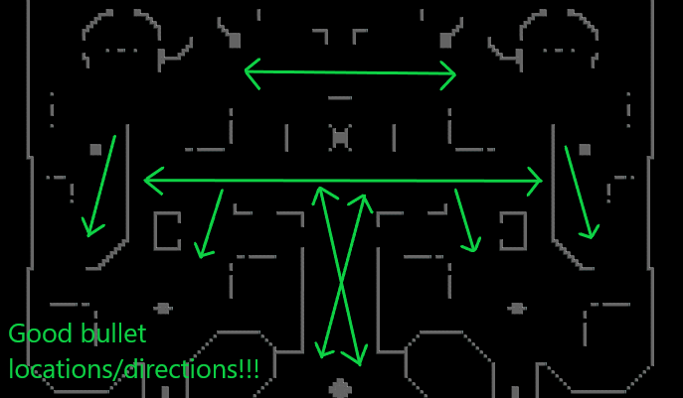

Bulleting down long verticals and horizontals at the enemy is the easiest way to gain and maintain control of the base. But it’s important to understand that if you’re not bulleting directly at the enemy or where they want to go, you’re doing nothing. If the enemy is above you when you enter base, bullet on your way in. If, instead, your team is above you and no enemies are around, do not bullet at them, as this may cause confusion. Fire one slow then one fast bullet for overlap to make a tricky situation for any enemies in its path. How fast your bullets move is determined by your ship speed.

Trap Secluded Enemies
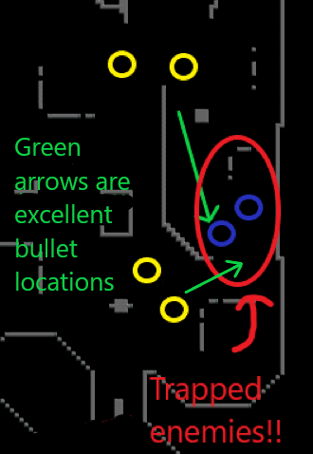

Every time I go to trap outnumbered enemies and my teammates fly away or take bad shots, leaving alive an otherwise completely dead enemy, a single strand of hair falls out of my head. If you find yourself on the verge of trapping the enemy, hold your shot and bullet at them to limit their movement. They’re in a bad situation and are desperate to either run away or trade 1-for-1. This is the easiest time to bait a bomb. If they miss then that’s a free kill. If they kill you, your teammate cleans up. This is optimal play because there’s very little risk involved and your team will usually come out ahead. If your team manages to get the formation above then those bullets are deadly. The enemy won’t have enough energy to bomb and you’ll get 2 free kills and a tilted enemy team.

The Threat is Greater Than the Execution
Just because you have 1500 energy doesn’t mean you need to fire at the first thing you see. If you fire every time you're even remotely in danger, it becomes obvious and easy to exploit. If you learn to hold your shot (“Until You See the Whites of Their Eyes”), players are less likely to attack you because you're that much less predictable. If I aim at you but hold my shot, then you dodge, you’re now moving more predictably and have less energy/worse positioning to counter-attack with. Now I have an advantage I can exploit and I can more safely attack you. Elite players absolutely hate it when beginner or intermediate level players hold their shot or refuse to dodge when we’re threatening them. They’re not moving predictably and while it is an objectively stupid game decision, it can work in the right time and place, in moderation.

Take More Safe Shots and Fewer Dangerous Ones
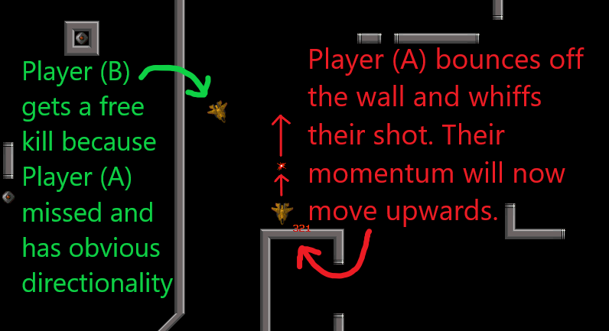

If an enemy is chasing you and you attempt to bomb off the same wall you’re bouncing off, you’re dead if you miss. Any time you bounce off a wall, your movement is at its most predictable and easiest to punish. On top of that, it’s unlikely that your bomb will connect from situations like the one Player A is in. This is because you can only fire as you move towards the wall, which makes the shot and its timing more obvious.

There’s a Better Way to Go About Things
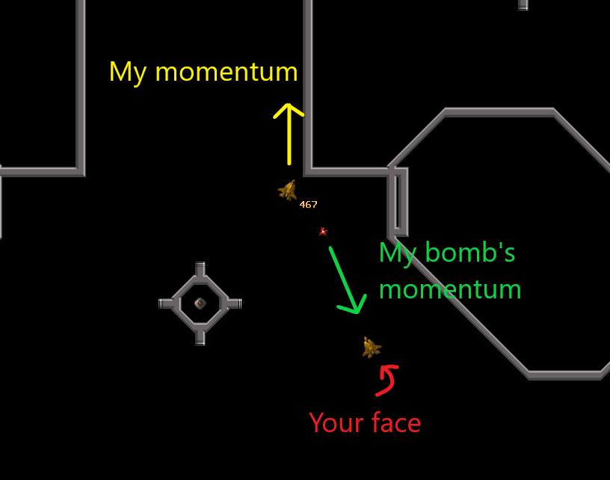

This is a much more ideal situation. I’m bombing off a wall while moving away from my enemy. This is ideal because my enemy needs to shift lots of energy to close the gap between us, but I can just continue to move away from them. Even if I miss my shot and they try to punish me, they’ll need to shift toward me and then recharge energy. This makes any possible attack on me much easier to predict and more easily dodged.

Stop Giving Freebies
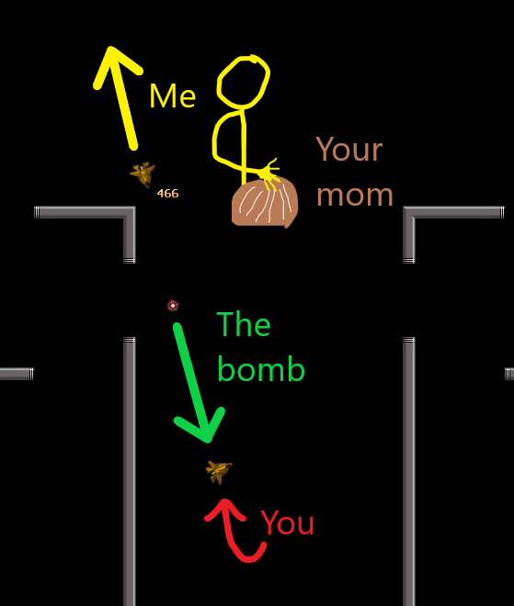

A freebie (or free shot) is any time your opponent can attempt to kill you but you can't punish them afterwards. It's free. As you can see from this graphic, I’m shooting off a wall and you have no choice but to dodge while I get off scot free. This is zidane’s most effective tool and how he carries TWLJ finals games. Positioning properly is the most important thing when taking these types of shots. If you miss the wall completely instead of bouncing, chances are your shot missed and you’re now at the mercy of the enemy team.

Stop Facing Away From your Enemies
This is true for all situations in jav where you’re not at a complete disadvantage. So if the situation is neutral or in your favor, you should NOT be pointing your backside toward your enemy. Now why is that? Pointing away from your enemy indicates weakness and a lack of confidence. You’re giving all the power to your enemy and telling them that they can shoot first. This is especially true when it comes to 1v1 situations where a wall stands between the two of you. If you’re facing away from me, I can set up my shot, fire off the wall into you, and then run away without you being able to retaliate. If, instead, you were facing me and actively threatening shots, it would mean I have less chances to kill you.

Shift into Base after Deaths
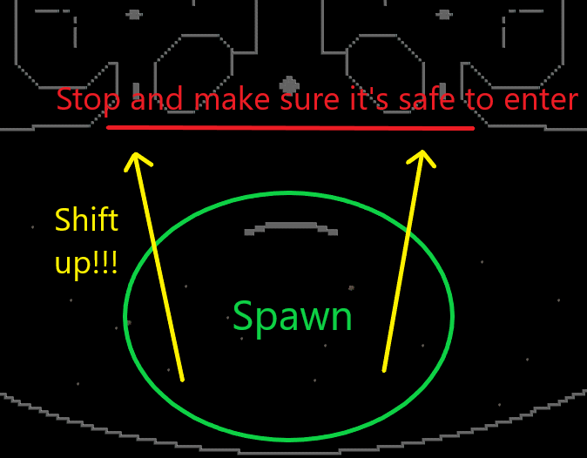

You just died so it’s time to take a break eh? Wrong. Use this time to keep track of where your team is headed and make a decision to shift to the left, middle, or right tube. Stop just shy of the entrance and watch your radar for any strays before heading in. If your entire team wiped and is in spawn, enter together slowly and carefully. There's no reason to enter base while under fire because there's no punishment for staying just outside of spawn. If you recently died in a battle near the “Do Not Cross” line, chances are you can shift back to where you were and pick off a low energy enemy with bullets. If you run back into base to try to save a teammate that’s 1v5, chances are you’ll die with them. This is your fault. Recognize the situation and respond appropriately.

Controlling the Base Means Controlling the Game
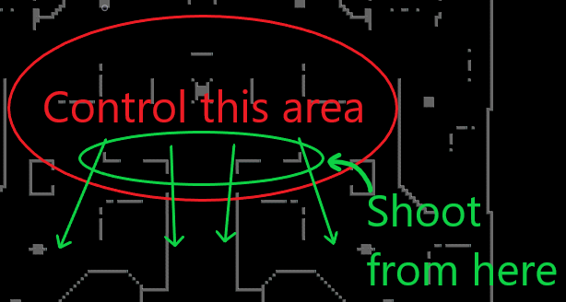

At the beginning of the game your goal is to rush upwards and challenge the enemy team for space in whatever way you can. This means bulleting down long horizontals and bombing to cut off/kill/make the enemy team dodge. If your enemy doesn’t challenge you in the middle of the base, this is your chance to take over their side of the base. Once you control base, you have the freedom to go where you want and do as you please. Getting higher vantage points mean more free shots at players trying to enter base or challenge your position. Not taking these free shots when available is a waste of an opportunity. Every time you have 1500 energy and you're not shifting to your team, with your team making plays, or firing off bombs means you're wasting precious time and lessening your impact. That doesn’t mean you should freak out every time you have 1500 energy, but you should consider when you could be spending your time more optimally. It’s perfectly okay to have 1500 energy when you’re in a spot controlling space or battling for high ground.

Stop Recycling Moves
Going green is great but if you keep taking the same shots with the same timing or using the same dodge in tough spots, people are going to notice and take advantage of it. We play a small game with a tight-knit community where people are going to eventually recognize your patterns. Catch yourself in the act and change the habit. Another great strategy that I see is playing one way in TWD, then playing completely differently in competitions. This is the coward’s strategy but it is effective.

Start Including Single Bullets in your Game
Players miss free kills every game by not taking advantage of the single bullet firing rate. After bombing you have 1500 – 1100 = 400 energy, so it only takes a second to recharge 121 energy to tank a 520 damage bullet. If you hit them with a multi-fire bullet they can tank it and get away easily, but if you use a single-fire bullet followed by a multi-fire bullet then they are almost guaranteed dead if the first bullet lands. Single bullets are most effective when you’re directly on top of an enemy because they cannot miss. If I’m on top of someone who has 650 energy and I bullet them, that leaves 650 – 520 = 130 energy for them to attempt to escape, which all but guarantees the kill. You want to be sure to use a multi-fire bullet for your second bullet because of the superior spread.

Use Walls to be Tricky
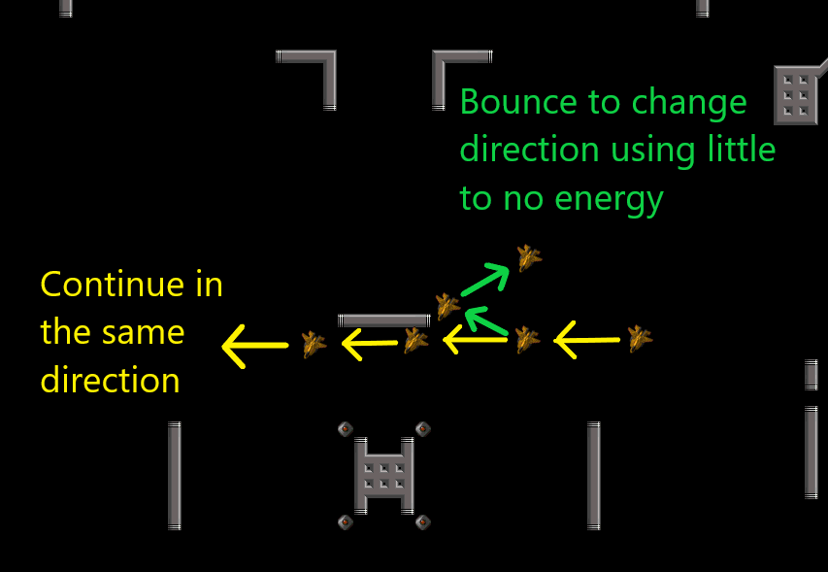

If you fly close to a wall there's no way for your opponents to know if you're going to bounce off it or keep going. This deceptive act can help you escape dangerous situations or turn around and punish someone chasing you frivolously. If you or the server are lagging? Even better because the game sometimes registers you bouncing off walls when you actually didn’t (lagging through walls). The caveat here is that flying close to walls can get you killed, so watch out for any bombs headed your way. Another drawback is that bouncing off walls too often can become predictable/stale and is punishable if anticipated. This is because the momentum change from bouncing off walls makes your movement predictable for a short period of time. If you find your enemy anticipating your wall bounces, you can bait bombs when they think you’ll bounce off a wall but don’t.

Change Your Momentum by Tapping the Shift Key Instead of Holding It
Completely changing direction by holding shift for 300-450 energy is a waste when you can tap shift and use 100-150 energy instead. The key is to shift to halt your momentum, fly normally without shift in the other direction until you gain speed, and then shift again if you need to reach full speed. So you’re only using shift to stop your momentum and speed up.

Use Anti-warp
Turn on anti-warp at the start of the match and each time you spawn. Turning on anti-warp prevents cheesy warps in spawn when you have a player outnumbered or intend to spawn kill. Anti-warp is always a net positive for your team unless you die while activating it.

You’re Not Aiming
If you want to aim well, you need to master flying first. Your aim is best when you know your ship’s orientation without looking directly at it. Once you have that down, it’s time to stop firing in general directions and start aiming at exact spots. Aim your bombs by choosing an exact path where you want it to bounce and then explode. When your enemy is far away (R3-R4), you’re better off focusing on their ship while using your peripherals to view where you’re turned. The closer your enemy is (R1-R2), the more you should actually look at the nose of your own ship while keeping your enemy in your peripherals. Your aim is also controlled by your momentum. This is true for most ships, but is especially true for jav because of its slow projectiles. This means that taking the same shot with different directionality or speed causes a completely different outcome. The best advice I can give you here is to try bombing through a hole from varied angles/speeds then observe the result. ELITE AIMING TIP ALERT: keep in mind your opponent’s movement patterns and look at the direction of their ship when aiming. If I see YojimbO^ turning away from me I’m going to assume he’s running at full speed, but if I see tripin turn like he’s going to run away, I know he’ll usually fake back and forth. Above all else ?go #twlj and practice shots that are different from what you usually take. I know that when turban (and I) made a map for ?go twjd, he spent a few hours in there flying around and learning shots. If he’s doing it you should probably do it too.

Vulch for your Teammates!
This is a basic skillset that every player needs to have in their arsenal. If you see someone on the enemy team bomb while they’re outnumbered, you should be diving in to finish the kill. Keep in mind that overcommitting by expending too much energy can lead to a sub-optimal 1-for-1 trade. When you have more energy than or outnumber your opponent its easiest to shift in and bullet them. It’s best practice to shift in and hold your bullets rather than use them immediately. Bulleting immediately is predictable and will cost you -300 energy and the kill. If you hold your bullets, you’re prepared for your enemy to dodge. So you rush in, wait for your opponent to react, they either run or change direction, then you rush in again and repeat this process until you have a clean shot. RaCka is particularly good at vulching because he flies at an angle whereas most players make a B-Line toward the enemy. Flying at an angle can allow you to avoid your opponent’s bullets while hitting them with your own when you land directly on top of them. The process for vulching using bombs is the same, except you’ll need to be extra careful about your enemy dodging toward you and bulleting you if you miss. We’ll discuss this in greater detail in the next section.

Bomb Decision Making
When to bomb and when not to bomb – this, along with aiming, is the toughest skill to perfect in javelin. Everyone fires bombs that have a 0% chance of hitting the enemy, so it’s important to learn when you don’t have the spacing/momentum/pressure to kill someone. One of the cleanest ways to kill is by getting in position to shoot before your enemy. That way you shoot and bounce away before they have a chance to retaliate. If your bomb is on point, your enemy has to dodge or they’ll die, which leaves no chance for counterplay. One of the best ways to get into position before the enemy does is to watch their momentum, predict where they’ll be, then change your momentum accordingly to set up a shot. Changing speed then shooting off a wall into the enemy is something turban does well.

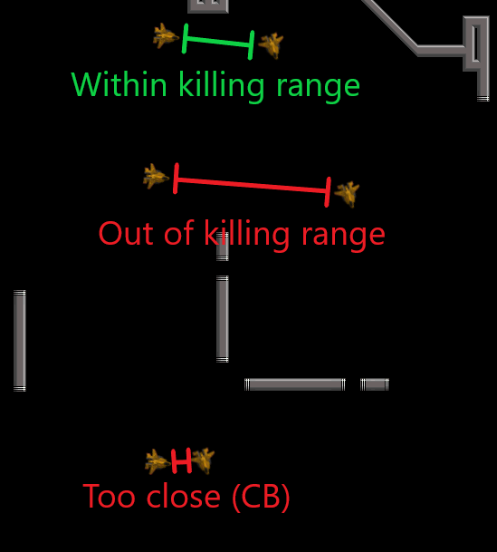

Ease, on the other hand, judges the distance between his ship and the enemy to determine if they’re within killing range. This is what’s known as an effective range. Elite players spend more time in the effective range or just outside of it attempting to bait a bad shot. Understanding the effective range is no different from understanding a boxing opponent’s arm length. The laggier the player, the longer their arms are. Another important concept is taking shots that focus on your or another team member’s safety. These are what I call deterrent shots and they’re par for the course of defending not only your teammates, but also yourself. Let’s say you have full energy and are chasing someone with 500 energy. You have the option of shooting where they are now, where they’ll be if they run away, or where they’ll be if they dodge into you. A deterrent shot in this situation would be the safe option of shooting somewhere between where they are now and where they’ll be if they dodge toward you. If you bomb anticipating that they’ll run away, but they dodge towards you, then it’s easy for your enemy to bullet and kill you even though you started with an energy advantage.

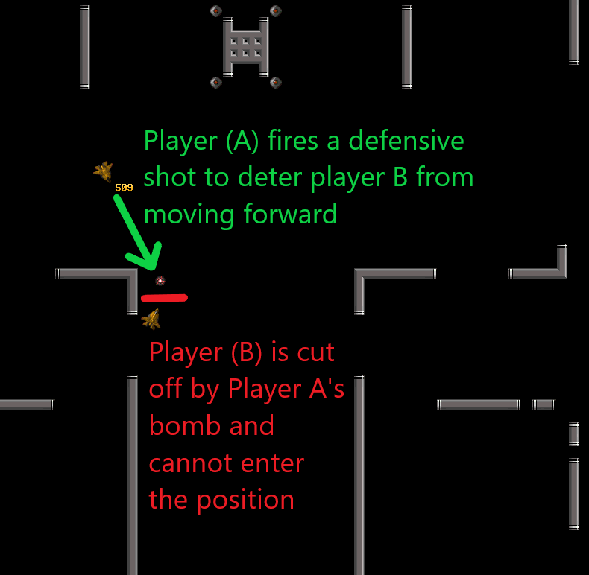

This is another example of a shot that deters aggressive behavior. Not all deterrent shots are good shots and taking these too frequently can lead to predictability. Be careful of players who routinely lure shots and situations where bombing will encourage nearby enemy fighters to swarm you. It’s also important to know the timing of when a player can bomb after tanking bullets. If I start with 1500 energy and you hit me with a bullet at very close R1 range, I can bomb and kill you before you have a chance to bullet again. It’s equally important to know how soon you can tank a bullet AFTER bombing with 1500 energy. After bombing with full energy you would have 400 energy. 521 energy is the minimum needed to tank a bullet. The time it takes to recharge 121 energy is VERY short and may surprise you.

How to Stray Better
While lobs oftentimes get a bad rap, they are a key component of having a complete game in jav (think triple threat in basketball). More often than not, close games will turn into lobfests where each team is trying to thin the enemy herd then push with a numbers advantage. Here are a few tips for improving your strays: bouncing off walls while shooting makes your bomb appear later and look faster. Shifting 400 energy and bouncing while bombing off a wall will make your bombs appear even faster. While this makes your bombs more dangerous in theory, shifting can make it hard to set up properly and aim a good shot. Predicting where your enemy will be is something you have to practice in order to do effectively. I always keep in mind who I’m shooting at and what their dodging patterns are. For example, if I fire at Mean Gene I know he is typically going to dodge backwards or no-dodge me, whereas other players might instinctively run away at full speed. You’ll also want to choose an exact path for your bomb rather than lobbing mindlessly. If you can use aim accurately while looking at the direction of the enemy ship, you’re now an elite lobber who should put up many R2 and R3 kills per game.

Juke More Effectively
Juking is the ultimate form of deception and is something that everyone should have in their kit. Some good jukes are wiggling back and forth, dodging toward your opponent rather than away from them, and no-dodging (the most elite but braindead dodge of all). The worst dodge in the history of the game is one where you react to everything your opponent does. This makes you predictable, puts you in danger, and wastes energy. Instead, be cool, calm, and collected and play comfortably within your enemy’s kill range when you have to. Remember that javs have an incredibly slow turn rate so in order to kill you, they have to accurately predict where you’ll go, position for it, then aim and time their bomb accurately. Above all else, do not dodge into your enemy’s aim. If I’m holding my aim at a certain point and you dodge into it, you’ve just killed yourself. But if I change my aim to where you are at the same time as you dodge to where my aim used to be, my shot will miss. Learning this timing is crucial to effectively juking.

Avoiding Strays, TK’s, and 2fers is Your Responsibility
If your teammate fires a bomb that’ll explode on a wall near you, it’s your job to hold your bomb and dodge appropriately. If your teammate lobs an R4 across the map and you die to it, that’s completely your fault. If your teammate has 0 energy and catches a 2fer near you, you should have recognized the situation and not put yourself there. The responsibility is only on your teammate when there was something they could have done differently. If you fire a bomb that’s going to bounce back near your location and kill a teammate, then you need to jump in front of it and tank the damage. Doing so will put you at zero energy and the bomb will do less damage to your teammate.

Cover Your Teammates
You and your teammate bomb at the same time then get rushed by the enemy team and 2ferred. What went wrong here? Well… Nobody covered. If you see your teammate is going to bomb and the enemy team can retaliate, it’s up to you to threaten and deter with a bomb or bullet while running away. You don’t even have to fire, simply aiming at most players will cause a reaction. Another scenario: you see your teammate is looking to bomb but there’s a bullet headed toward them. Be proactive and catch it. In serious games bullets are used to control space and interrupt the offensive impact of enemy players. If you do things to let your teammates play unstifled, they’re going to have a better performance, and your team will come out ahead. Overcommitting to save a teammate is almost always bad so if you can’t get to them, throw some bullets out but remain passive. In the worst case scenario, they’ll die but you’ll live to fight another day.

Stop Watching Your Bombs
So you just lobbed across the map and watch your bomb like it’s a pinball. Bad idea. Watching your bombs is only good during practice to ensure your aim’s on point. In serious games, watching bombs will get you strayed and killed. As soon as you get your shot off you should be analyzing the current situation and deciding on the next course of action. If your bomb connects? Great. If it doesn’t, it doesn’t matter. You’re off doing the next thing.

Bad Bullets Are Getting You Killed
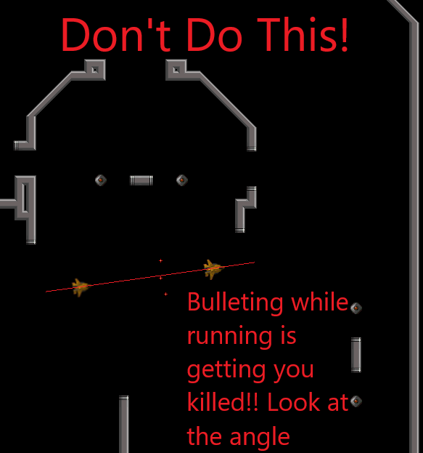

When flying in open space, bullets are easily dodged unless you’re very close to your attacker. Bulleting like we see here faces you in the same direction as your attacker, which means that if they bomb, you won’t be able to turn to dodge in time.

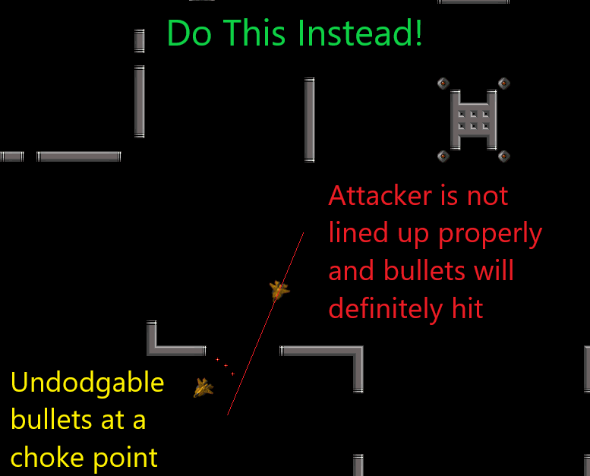

This is a much safer situation to bullet in for a variety of reasons. The attacker isn’t lined up to shoot. The bullets are undodgable (unless the attacker slows their momentum). If the attacker has 1500 energy, they can bomb and completely stop their momentum to dodge the bullets, but it’s risky. The bomb has very little chance of hitting the running player because of the distance between the players and the angle of the guy running.

Bomb When You Have 1500 Energy, Not 1100
I know it’s tempting, but spamming bombs is more likely to get you killed. If you wait until you have 1500 energy to shoot, you’ll have 400 spare energy to dodge, tank, or react to what happens next. Shooting at 1100 energy (especially after shifting forward aggressively) leaves you helpless and puts you at a disadvantage. That’s not to say that shifting forward is bad, it’s just another situational tool that you need to learn how to do in moderation. Shooting bombs at 1500 energy provides other situational advantages. It allows you to fire a second bomb faster than if you had to recharge from zero. This oftentimes surprises your opponent who wrongly assumed you were vulnerable. Roiwerk (defensive jav of the year) does this more often than anyone else. He strays at 1500 energy, the enemy chases him aggressively, and while running he shoots a deterrent bomb as soon as he has enough energy.

Dying to Laggy Players is Your Fault!
Speaking of Roiwerk, this one’s a hard pill to swallow. Playing in a small community means that you know who lags, which means you should know when you have less time to dodge a lagged bomb. When facing laggy players, I keep more distance and I keep in mind the laggy player mindset which is “I’m going to shoot very predictive shots because my enemy has less time to react.” This means that I dodge less when facing them. Doing this usually catches them by surprise because you are expected you to panic. Keeping your distance and playing less reactively to laggy players will generally lead to better outcomes.

Spawn Killing is Part of the Game
Speaking of hard pills to swallow, this one might block your airflow. I’m sick and tired of seeing people whine about spawns and I’m ESPECIALLY tired of seeing people who spawn kill whine about spawns. If you fall under either of these groups, you’re a bitch and you need to change. Spawns have been in the game for 20 years with no signs of a system to prevent them, this means they’re part of the game. Every single person has spawn killed someone. If you’re actually part of the rare 1% of people who don’t spawn kill, you’re just not a competitor and this guide may not be for you. Little known fact: your ship is locked from bombing for a short period of time after you spawn. This means that if you die and an enemy dies a few seconds later, you now have an exploitable advantage. After you spawn, immediately turn on anti-warp and aim at a common spawning point for a potential free kill. Pay attention to the scoreboard to see if you’ll be getting backup or outnumbered in spawn. If your enemy spawns far away from you, this is a sign from above that you shouldn’t be fighting in spawn. It’s a waste of time to attempt to force fights in spawn without 3 or 4 teammates around. Equally useless is bombing at someone running into base in the majority of situations. Shooting blind R4’s down mid-tube from spawn is also a waste of time when you consider that the bomb has an equal chance of killing players from both teams after it bounces. So if you don’t get a chance at a free spawn kill, simply shift upward and join your team in battle.

Watch Radar More Frequently
JAV. BOMBS. SHOW. ON. RADAR. This means that 90% of the time when you die to a stray, it’s your fault. If you dart your eyes to your radar more frequently, you’ll save yourself from avoidable deaths and gain awareness of the current situation in game. If you’re entering base and see an enemy fire a shot, it’s now your job to rush and kill said enemy.

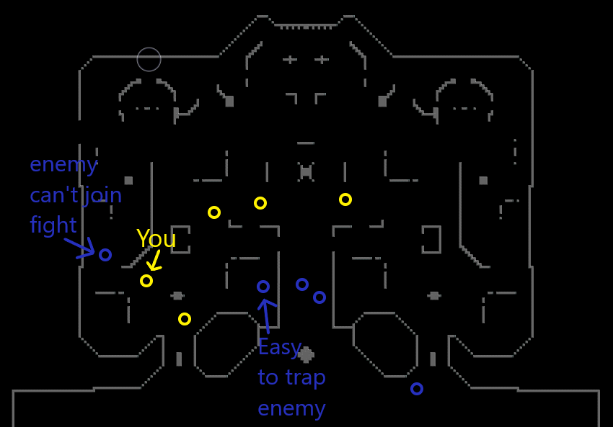

This situation happens ALL THE TIME. Your team owns base. The enemy all the way on the left is completely safe from you because he’s hiding behind the wall. If you attempt to kill the enemy hiding behind the wall, you’re at a strategic disadvantage by chasing him. If you were watching your map you’d see that multiple enemies are struggling to enter the base and your team has a numbers advantage. In this situation, you have multiple options for favorable outcomes. 1. You keep the enemy trapped there by refusing to fight but holding your ground. This prevents him from contributing to the fight in mid but you can leave at any time. 2. You get the enemy on the left to move upward out of fear that you might kill them. Now that their momentum is moving upward, you change directions, go right, and trap and kill the “Easy to trap enemy.” Because you were watching your map and reading the situation, your team came out on top.

Entering Base from the Left and Right Tubes is Safer
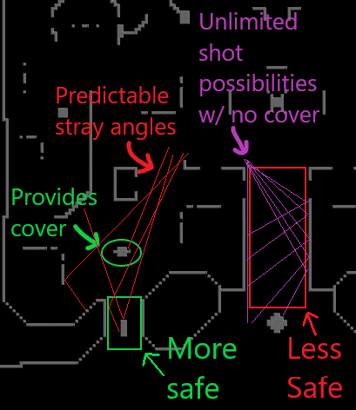

Attempting to enter from the center tube becomes very dangerous when you have 2 or more people covering it. Attempting to enter the center tube while under fire is basically giving your enemy unlimited free shots on you. Even if you bullet upwards while entering center tube, players can simply time their bombs to avoid your bullets and still get a free shot off on you. When entering from the left or right tubes, the stray possibilities are limited because the tube itself has cover and the blocks above the tube provide cover. This makes shots more predictable because there are significantly less angles to choose from and bombs will explode on walls without making it outside of base. The bombs that do make it out of base from the left and right tubes will have predictable trajectories. Entering base from anywhere can be dangerous. As always it’s important to assess the situation and see which tube has the least enemies firing down it.

How to 1v1 Effectively
Jav is considered a bunk ship when it comes to 1v1ing. This is because hiding behind walls is OP. If you find yourself down 47-49 where the enemy refuses to fight you, then you have no chance to kill that person and they can run the clock to victory. There’s nothing inherently wrong with doing this in 5v5 timed situations, but I’ll admit it is annoying. On the other hand, if someone runs indefinitely in a 1v1 untimed situation, you should just choose to never duel that person again and move on. If you happen to have two willing participants, here are a couple of tips. PUNISH PUNISH PUNISH. Your goal is to punish the enemy player heavily for any mistakes they might make. If they miss a bomb and you can chase them, do so indefinitely until you see a shot with a high chance of killing. Taking the first shot with any chance of killing is the sign of an inexperienced 1v1 player. Your job is to push your energy advantage as far as possible then turn it into a kill. If you have full energy but your enemy is aggressively closing the distance between you two, this is your chance to shoot free(ish) shots off a wall while running away. Winning duels is all about deception and creativity. If I can get you to react to me, your movement becomes more predictable. I know that if I aim here, you’re going to dodge this way, and then I can catch you off guard with an r2 shot off the wall.

Stop Tunnel Visioning
Punishing in 5v5 situations is completely different from punishing in a 1v1 and will need to be handled differently. In a 1v1, you have the entire map to chase down and gut your opponent like a fish (holyyyyy) whereas in 5v5 you’ll run into bullets, vulchers, and teammates covering their bros. It’s easy to get carried away while chasing someone, get hit with stray bullets, then die with no counterplay. This is tunnel vision and it’s caused by fixating on the enemy in front of you rather than watching your peripherals and the radar. In 5v5 situations, you need to recognize when you’re cut off from chasing any further. When this happens, you may want to settle with a bomb that has a decent chance of connecting.

Thanks for reading, have fun in SSCU Trench Wars!

